

**High Level Design &** **Low Level Design**

**Index**

**1. Introduction** ------------------------------------------------ 3

1.1 Intended audience ------------------------------------------------ 3

1.2 Project purpose ------------------------------------------------ 3

1.3 Key project objective ------------------------------------------------ 3

1.4 Project scope ------------------------------------------------ 4

**2. Design overview**  ------------------------------------------------ 4

2.1 Design objective ------------------------------------------------ 4

2.2 Design alternative ------------------------------------------------ 4

2.3 User interface paradigms ------------------------------------------------ 4

2.4 Validations ------------------------------------------------ 5

**3. Detailed system design** ------------------------------------------------ 5

3.1 Flowchart of main application ------------------------------------------------ 5

3.2 Flow chart of database maintenance ------------------------------------------------ 6

3.3 Flowchart of show receipt of the application-------------------------------------------- 7

1. **Introduction**

The introduction of the software requirement specification provides an overview of the entire software. The entire SRS with overview description purpose, scope, tools used and basic description. The aim of this project is to allow users to book local train tickets and get ticket receipts online. The detailed requirements of the Local Train Ticketing application are provided in this document.

* 1. **Intended Audience:**

The target audience set for this project is the users who are allowed to book local train tickets and get ticket receipts online.

* 1. **Project Purpose**:

The purpose of this document is to show the requirements for the Local Train Ticketing application, in which it allows the user to register, login and get a ticket online, print it and travel by train.

* 1. **Project Objectives: -**

1. Allows user to register using Aadhar number, personal details, create password
2. Make a deposit of rupees 500
3. Login using Aadhar number and password
4. Select source and destination
5. Display train availability
6. Choose the respective train
7. Confirm/cancel booking
8. Generate receipt
   1. **Project Scope:**

This project aims to create the development of a Local Train Ticketing application. The ticketing process consists of a ticket booking form. The user can reserve the train ticket by giving the required details like source, destination, and date of journey and knows the trains list.

The user can select a train and check availability. If available, the user can give details in the form, payment details and submit it for processing. The local train ticketing application provides train tickets which users can view and take a print.

1. **Design Overview**

**2.1** **Design Objectives:**

If it is a new user then the user can register and then login and if it is an existing user, then the user can directly login using the valid Aadhar number and password.

The user should make an initial deposit of rupees 500 to proceed with ticket booking. The user can go for a daily ticket or monthly ticket. The user deposit should not be less than rupees 100. If the balance is insufficient in the user’s account, then the ticket is denied. After successful booking, the user gets the ticket receipt online.

**2.2** **Design alternative:**

We have used a linked list structure to store data i.e... Train name, source, destination, distance in kms, capacity, and fare per km.

**2.3** **User Interface Paradigms:**

The Local Train Ticketing system provides an option to users by generating their ticket receipt online automatically when they book their tickets, and the admin keeps the records of all users.

**2.4 Validation:**

* Aadhar number should be unique, and duplication is not allowed.
* Password should be unique, and it is valid if it contains at least 4 characters, at least 1 numeric digit, at least 1 capital letter, must not have space or slash (/) and starting character must not be a number.
* The user’s initial account balance should be 500 rupees.
* After login, the balance should not be less than rupees 100. If less than 100, the ticket should be denied.

1. **Detailed System design**

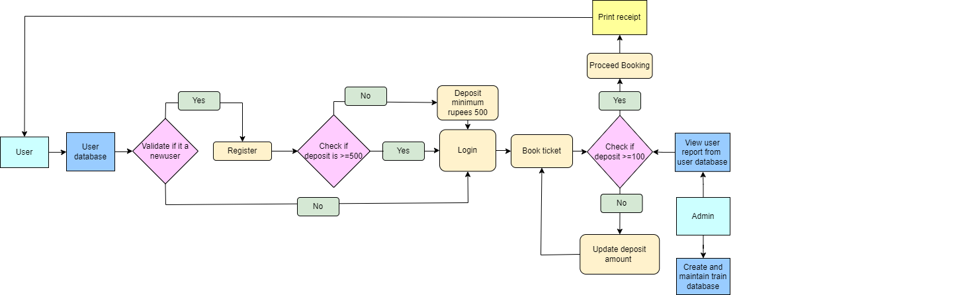

**Fig: 3.1** Flow chart of main application

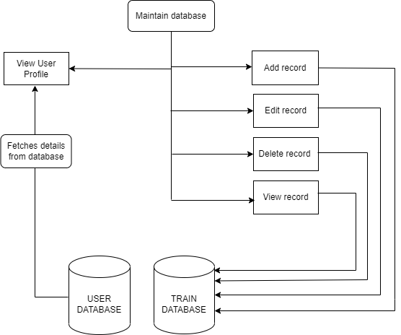

**Fig: 3.2** Flow chart of database maintenance

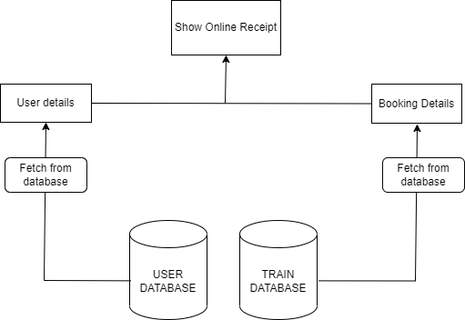

**Fig: 3.3** Flow chart of Show receipt of the application